**Unit Testing in Angular apps**

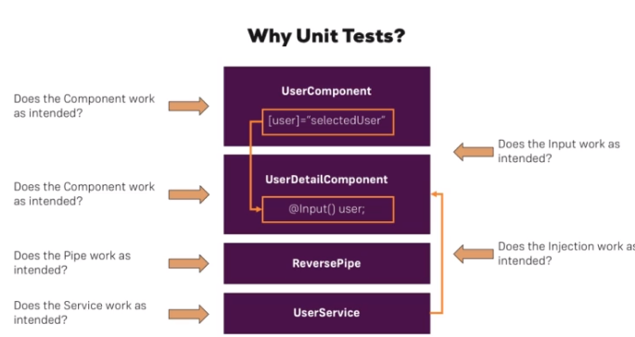

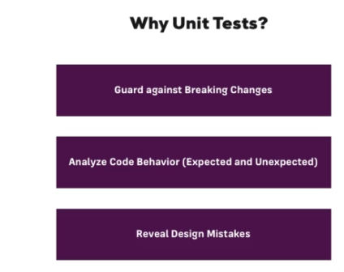

**Analyzing the Testing Setup (as created by the CLI)**

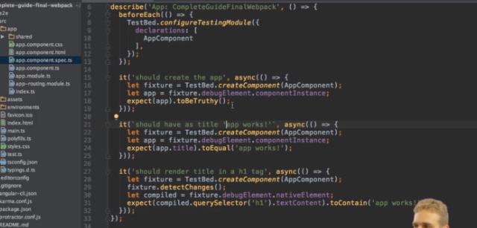

**Running Tests (with the CLI)**

ng test

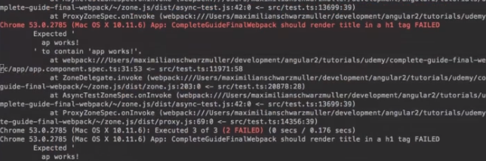

**Simulating Async Tasks**

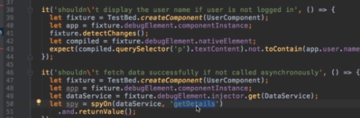

**Using "fakeAsync" and "tick"**

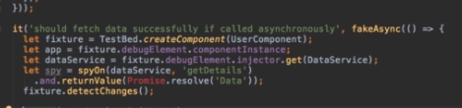

**Isolated vs Non-Isolated Tests**

